AirOps Automation Platform
A practical plan for moving seat procurement, airline coordination and AIS work into one supervised workflow.

Why build this
Today the work moves between Product, Airline teams, airline group tools, spreadsheets, email and AIS. AirOps should keep the request and its history in one place, let integrations handle repeatable steps in the background, and bring a person in when a choice needs judgement or approval.

What the platform should do
Product teams enter the seats they need. Airline teams request options and manage quotes. The platform compares fares, records negotiation and approval, prepares PNR and AIS data, and watches sales and deadlines. A Spectator (oversight operator) can see the whole workflow, handle exceptions and approve actions that the team has not cleared for automatic processing.

Who uses it
Role | What they do in AirOps
Product team admin | Enter sector, destination, travel period, seat count and preferred flight details; review fare options; approve a deal; decide whether unsold seats should be released.
Airline team admin | Work the airline requests, follow up on fares, negotiate with airlines, confirm agreements and oversee PNR or ticketing details.
Spectator / oversight operator | Monitor all cases, resolve exceptions, review system actions and approve uploads or release messages when approval is required.
Connected services | Airline group tools, AIS, the sales workbook and email exchange requests, fares, IDs, PNRs, inventory and notifications.

What a good result looks like
Teams can see what is waiting, what has happened and who needs to act. Routine work runs in the background; uncertain flight choices, mismatched data and commercial approvals are brought forward with enough context to make a quick decision.

How the pieces fit together
People work through their own AirOps views. AirOps keeps the case moving and connects to the tools the teams already use. The Spectator has one place to spot delays, exceptions and approvals.
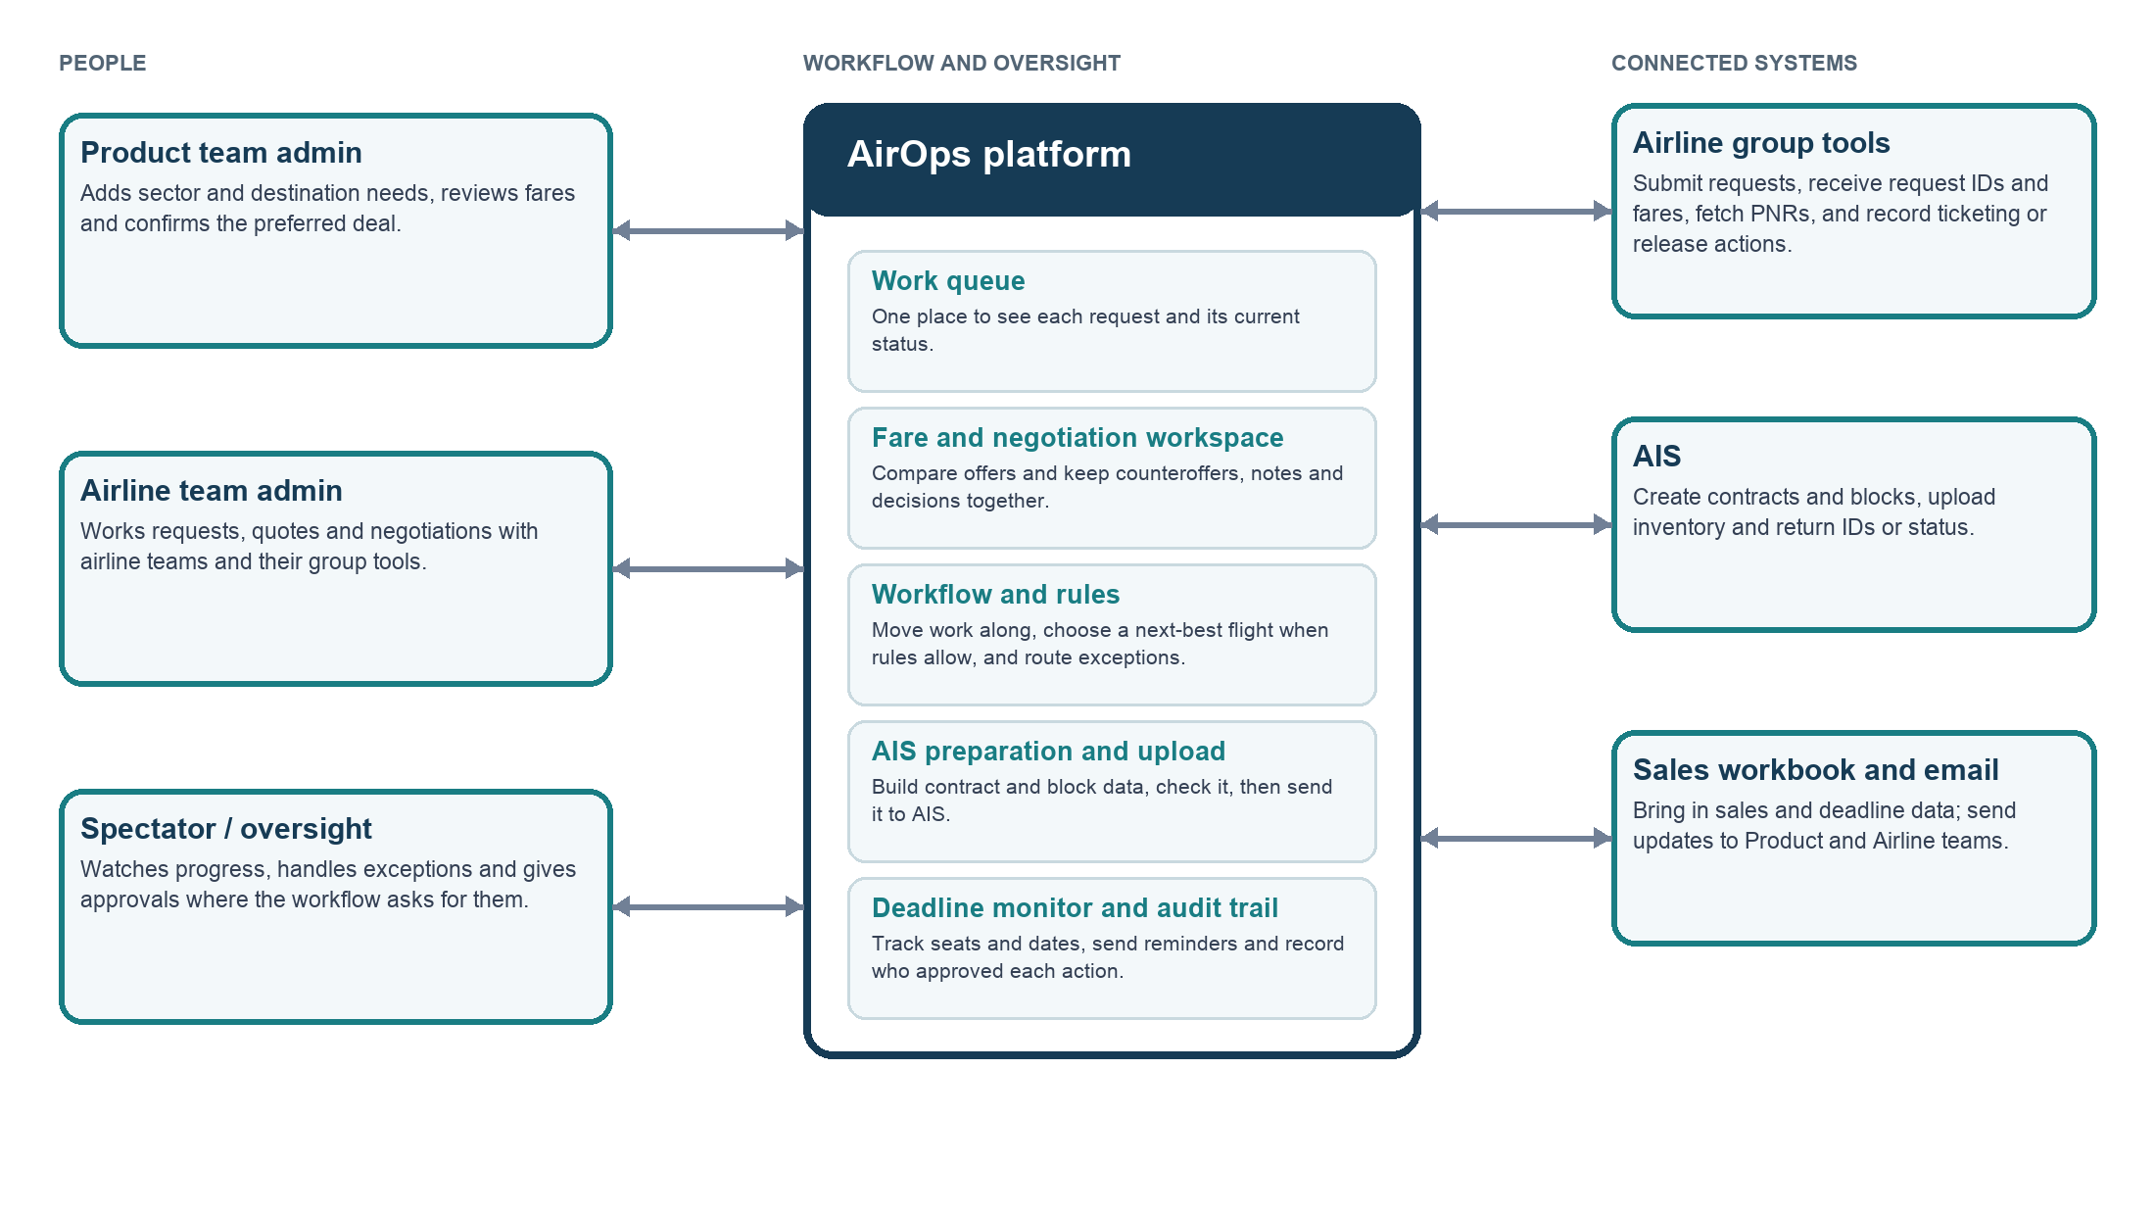
The diagram shows the proposed connections. The exact airline group tools, AIS interfaces and workbook data feeds still need to be confirmed with their owners.

How a request moves from need to inventory
A request stays as one case from the first seat requirement through the final release decision. Each stage adds its results to that case so the next team does not need to rebuild the history.
Stage | What happens | Decision or handoff
1. Set the requirement | Product enters sector, destination, date range, seats needed and preferred flight times, based on demand trends. | Product confirms the request is ready to send.
2. Request airline options | AirOps sends the request through each airline group tool and stores the request IDs and responses. | If the preferred time is unavailable, AirOps applies the agreed next-best-time rule or asks for a choice.
3. Compare and negotiate | AirOps brings returned fares into one view. Airline team records offers, counteroffers and notes in the negotiation workspace. | Product reviews the options and gives the go-ahead for a selected deal.
4. Confirm and prepare | Record the airline agreement, retrieve PNRs against the request IDs, and keep flight, date and PNR details together. | AirOps prepares the AIS contract and block data and checks required fields.
5. Review and publish | A Spectator or an approved rule reviews the contract and block package. AirOps uploads it to AIS, then confirms the inventory is available for sale. | Any rejected upload or missing value returns to an exception queue.
6. Track and release | AirOps follows seats sold or unsold and the ticketing deadline using AIS and the agreed sales data source. | As the deadline approaches, Product and Airline teams are notified. Product decides whether to retain or release; AirOps sends the airline message automatically only under the agreed approval mode.

What AirOps needs to handle
Capability | Expected behavior
Role-based access | Provide separate views for Product admins, Airline admins and Spectators. Show each person the cases and actions relevant to their role.
Requirement intake | Capture sector, destination, date range, seat count, preferred times and any constraints needed to send an airline request.
Airline request and PNR connections | Send requests through supported group tools, save each returned request ID, then retrieve and match PNRs to airline, flight, date and time.
Next-best flight | When the preferred flight time is missing, rank available alternatives using a rule the teams have agreed. Show the reason for the choice. Send ties, missing data or out-of-range times to a person.
Fare comparison and negotiation | Show received quotes side by side with the fields available from the airline. Keep each offer, counteroffer, note, meeting outcome and Product decision in the case history.
AIS preparation and upload | Build the contract from the approved deal and the block from the contract plus departure/PNR details. Validate required fields before upload and save AIS IDs and responses.
Sales and deadlines | Check inventory sales and unsold seats on a schedule. Alert Product and Airline teams before the relevant deadline and show the data used for the alert.
Release decision | Record Product’s retain/release decision. After a release go-ahead, either send the airline email automatically under an agreed rule or route it to the Spectator for approval.
Case history | Keep a time-stamped record of inputs, integrations, changes, approvals, uploads, errors and outbound messages.

Approval gates
The goal is automation with oversight. The team can enable automatic processing one action at a time after the rules and integrations are proven. Until then, AirOps should pause at the approval gate, show what it plans to do and let the right person approve or correct it.

Integrations and information the system needs
Connection | Information going in or out | What needs confirming
Airline group tools | Requests, request IDs, flight options, fares, PNRs, ticketing deadlines and release messages. | Which tools and endpoints are available, what each airline supports, and how credentials and limits are managed.
AIS | Contract and block uploads, generated IDs, upload status and inventory availability. | Supported upload method, validation rules, response format and safe retry behavior.
Sales workbook / sales data | Package sales, seat sales and unsold inventory used for deadline monitoring. | Which sheet or source is authoritative, how often it changes and how records map to AIS inventory.
Email and notifications | Deadline alerts, negotiation updates and airline release messages. | Recipients, templates, delivery logging and whether an email needs Spectator approval.

Decisions for the team
• Next-best flight: What makes a time the closest acceptable alternative? Set a maximum time difference and tie-breakers.
• Fare comparison: Which fare elements must be compared when quotes differ in taxes, baggage, flexibility or validity?
• Approval mode: Which steps can run automatically, and which always need Product, Airline or Spectator approval?
• Release timing: How far ahead should deadline alerts go, and which terms control the release cut-off?
• Data ownership: Which system is authoritative for requirements, PNRs, seat sales, contract/block IDs and deadlines?
• Integration access: Confirm airline and AIS access, credentials, service accounts, limits and permitted actions.

A sensible first release
Start with request intake, case tracking, fare comparison and a clear approval history. Add airline group tool and AIS connections in small steps, validating each one with a test case and a visible fallback. Turn on automatic flight selection, uploads or release emails only after the team agrees the rules and reviews the results.

Appendix A End-to-end operating flow
This is the current process view carried into the proposed AirOps platform.


